Task no1

Task no2

Task no3

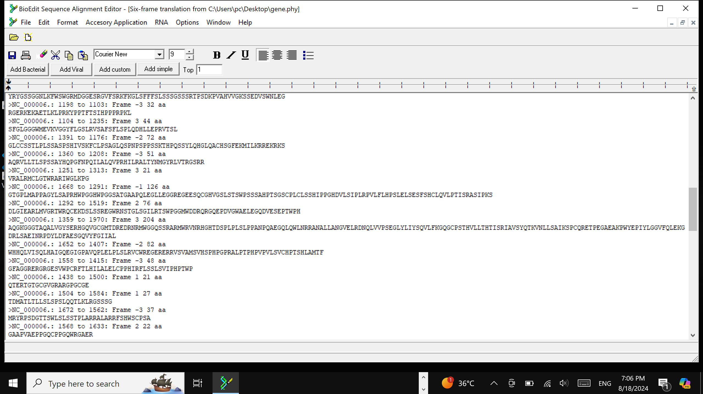

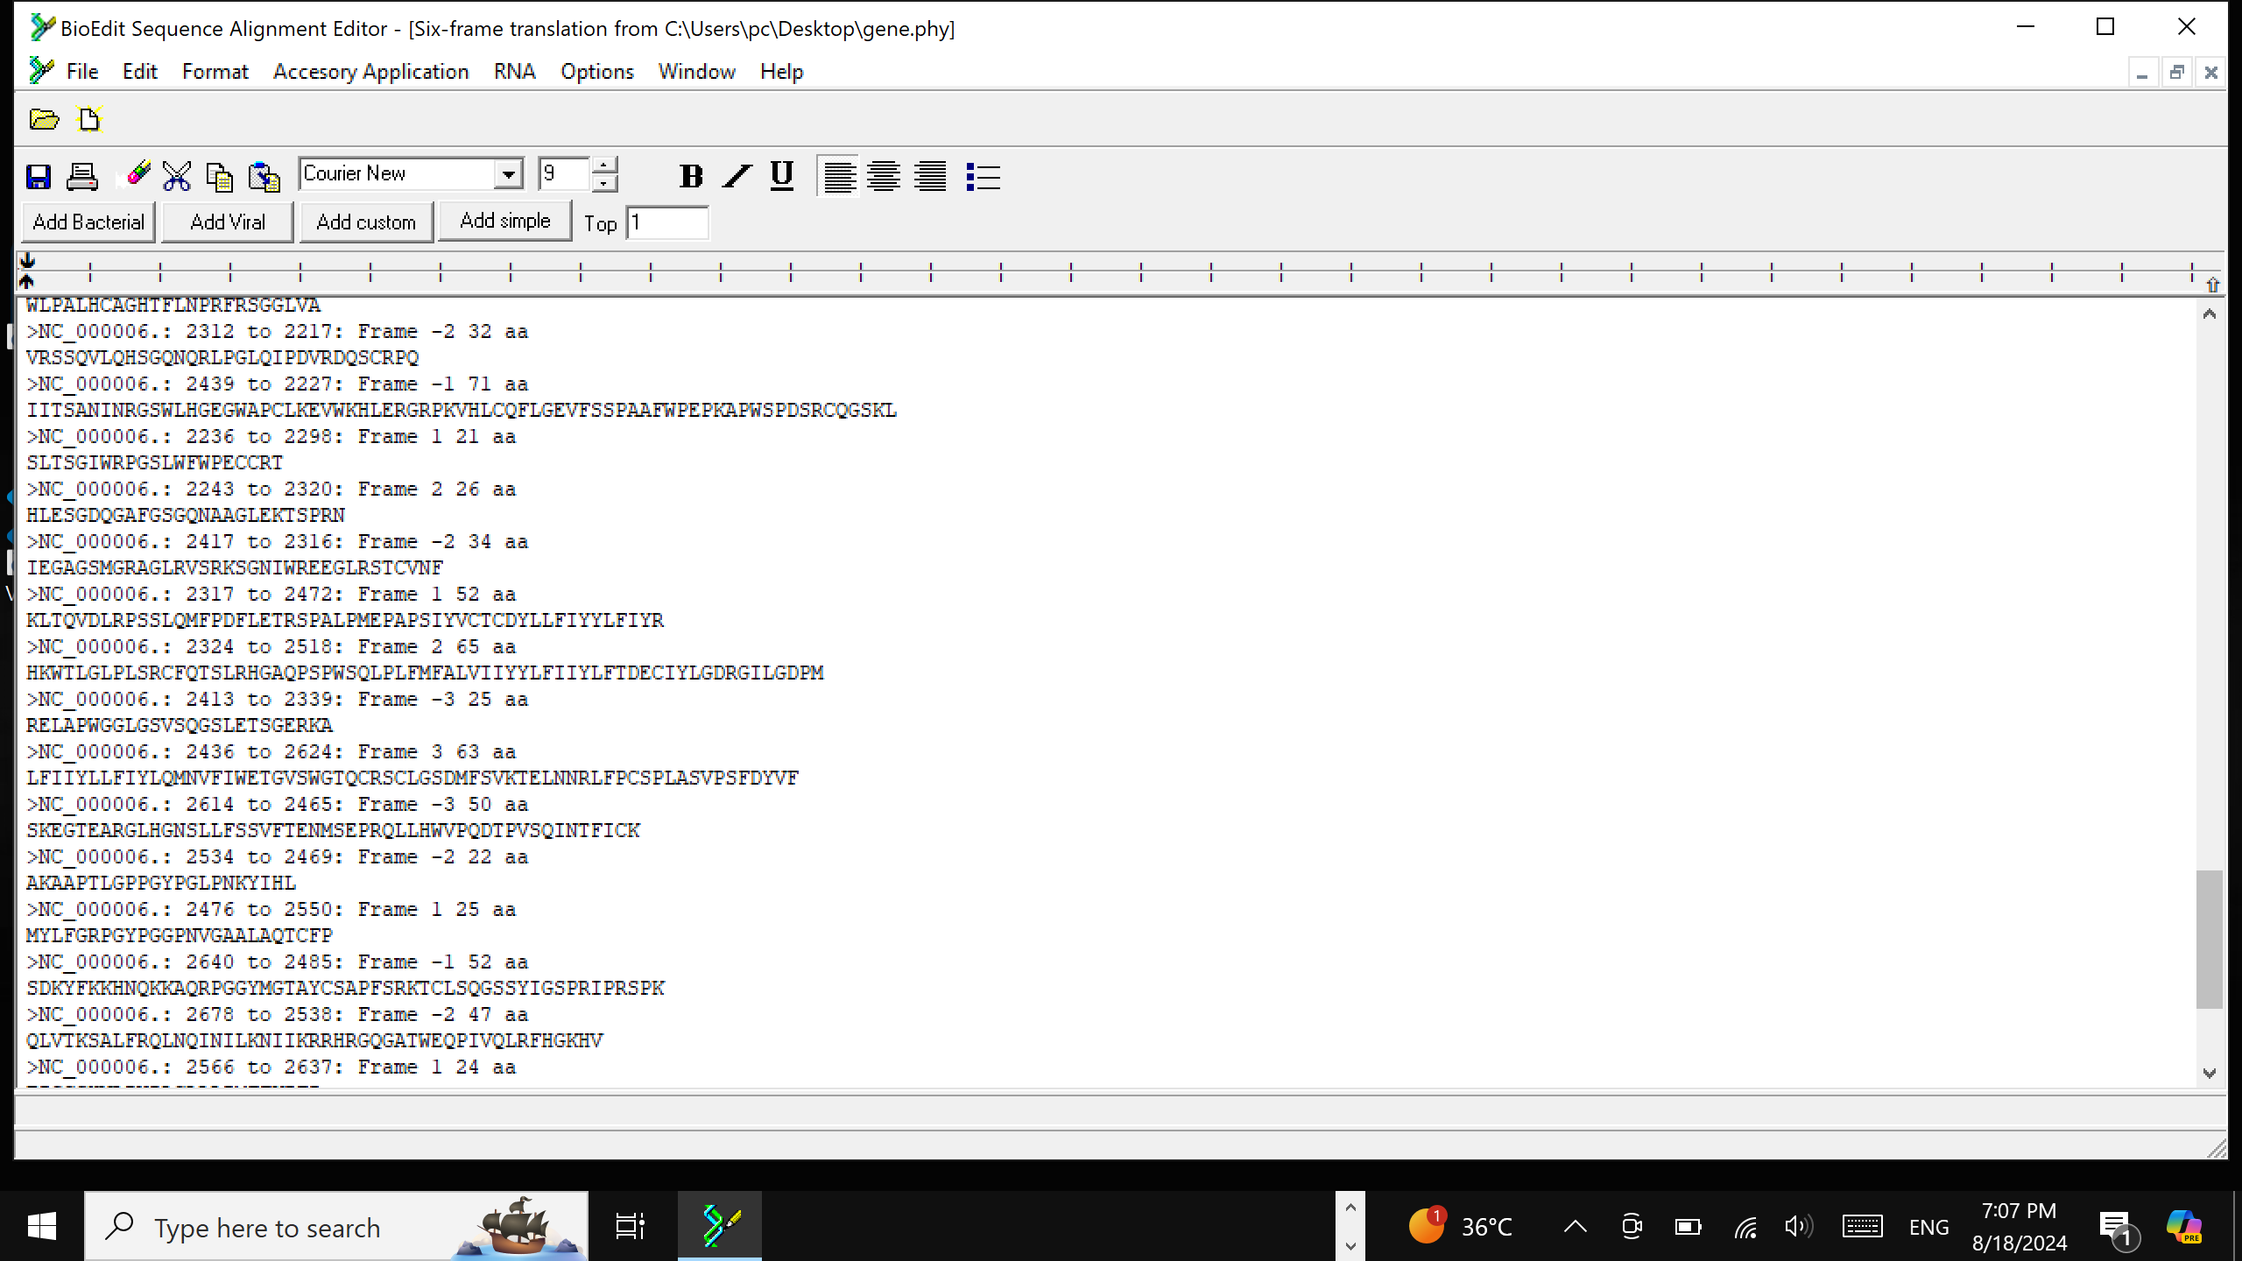

Task no4

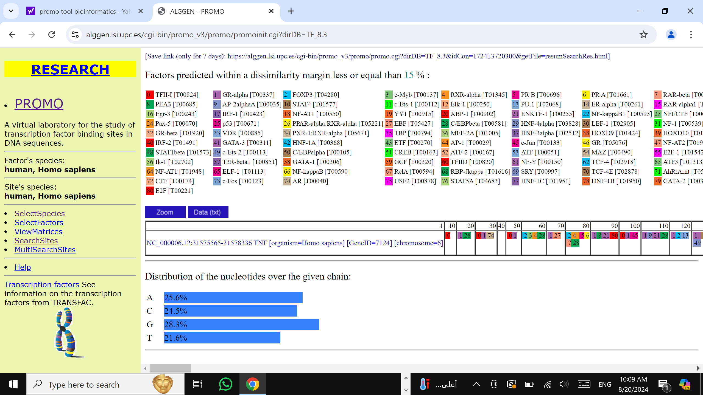Task no5

Task no6

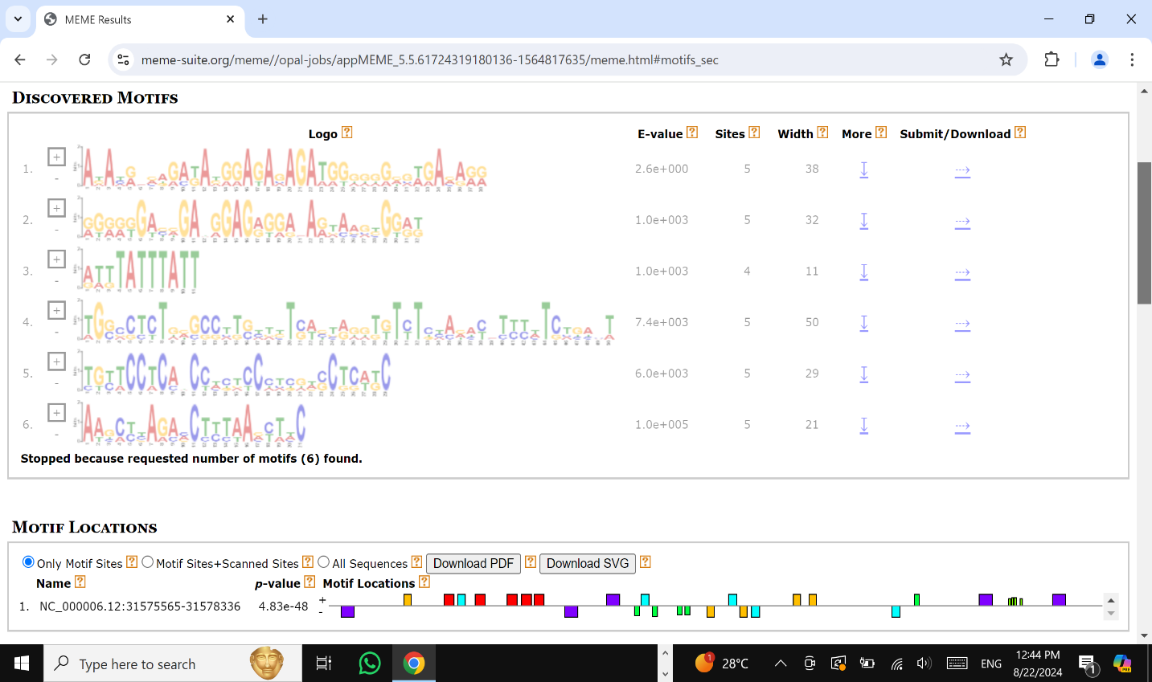

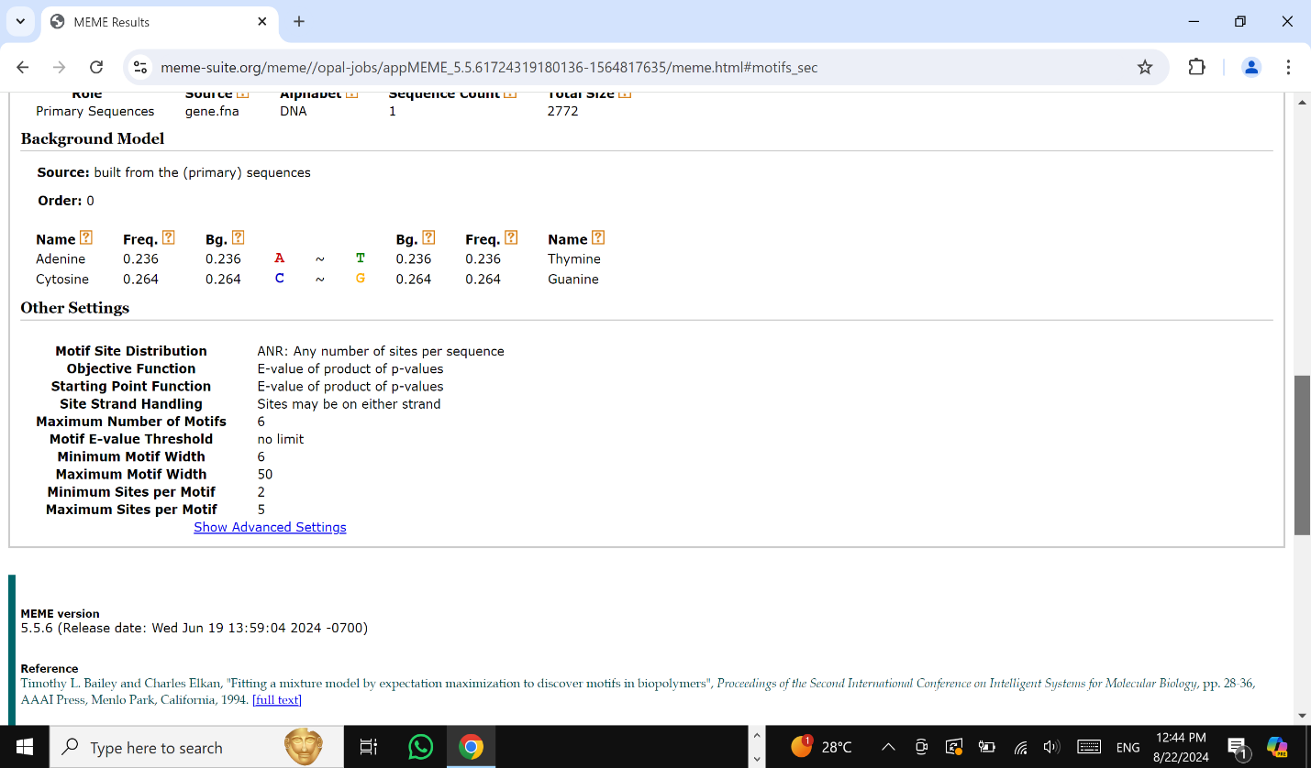

Task no7

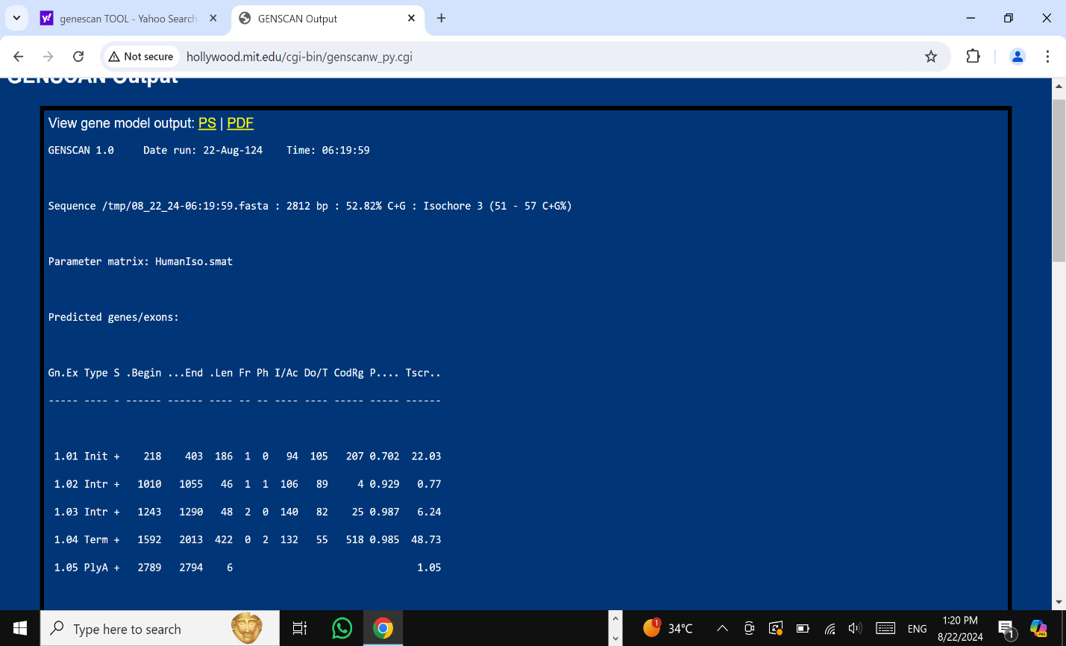

Task no8